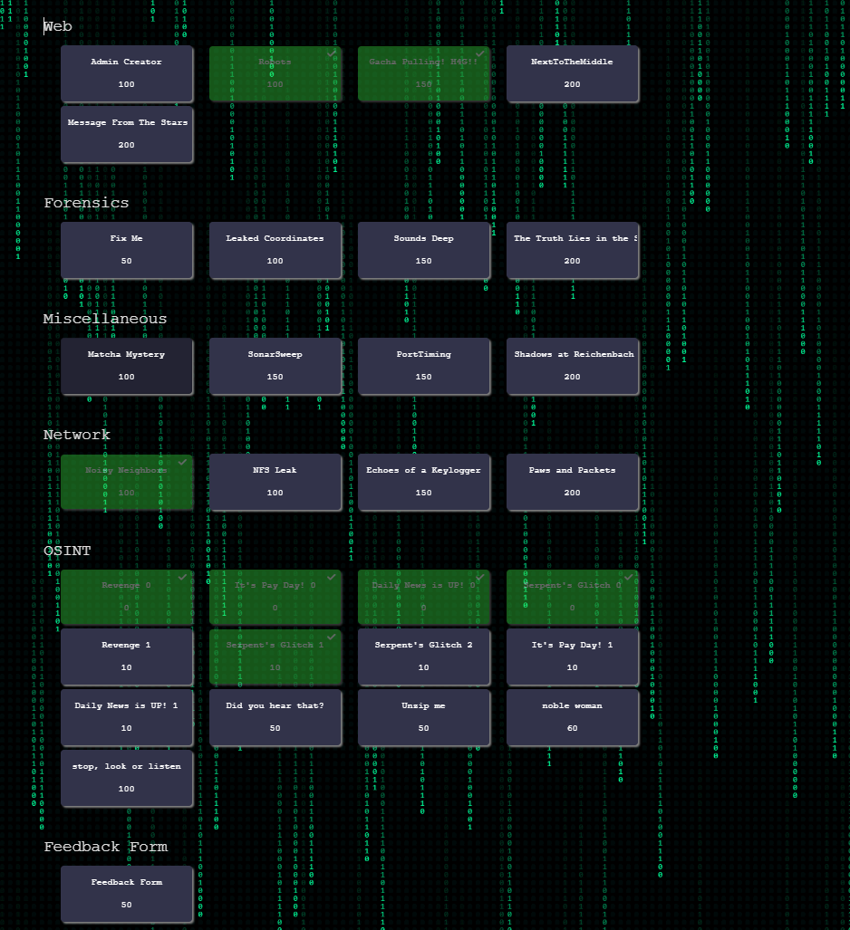

Admin Creator
100
A small web app was deployed with a hidden debug endpoint accidentally left open. With this there might be a way to get access to an admin account and make yourself an admin
http://172.16.101.205:5003
Flag Format: H4G{Answer}
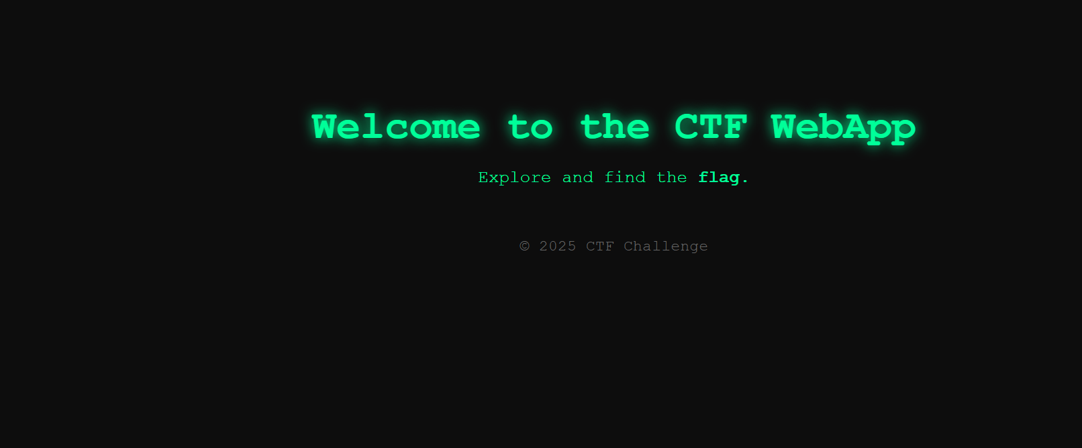

Challenge
NextToTheMiddle
200
There's a secret in this webpage... but every time you access it you get redirected, maybe it's something you're not suppose to see. Or are you?

http://172.16.101.205:5004

Flag Format: H4G{flag}

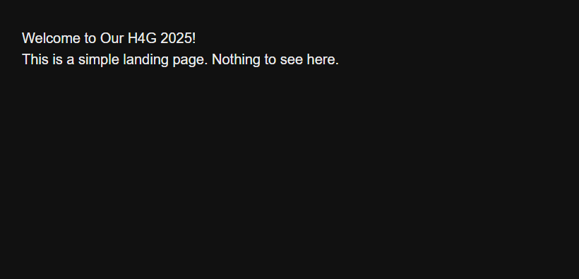

Message From The Stars
200
Quest: Retrieve the ?SIGNAL from /Messages_From_The_Stars.php. Collect all the messages. Observe the familiar pattern. Decrypt the code. Earn the Flag!
http://172.16.101.205
Flag Format: H4G{flag}
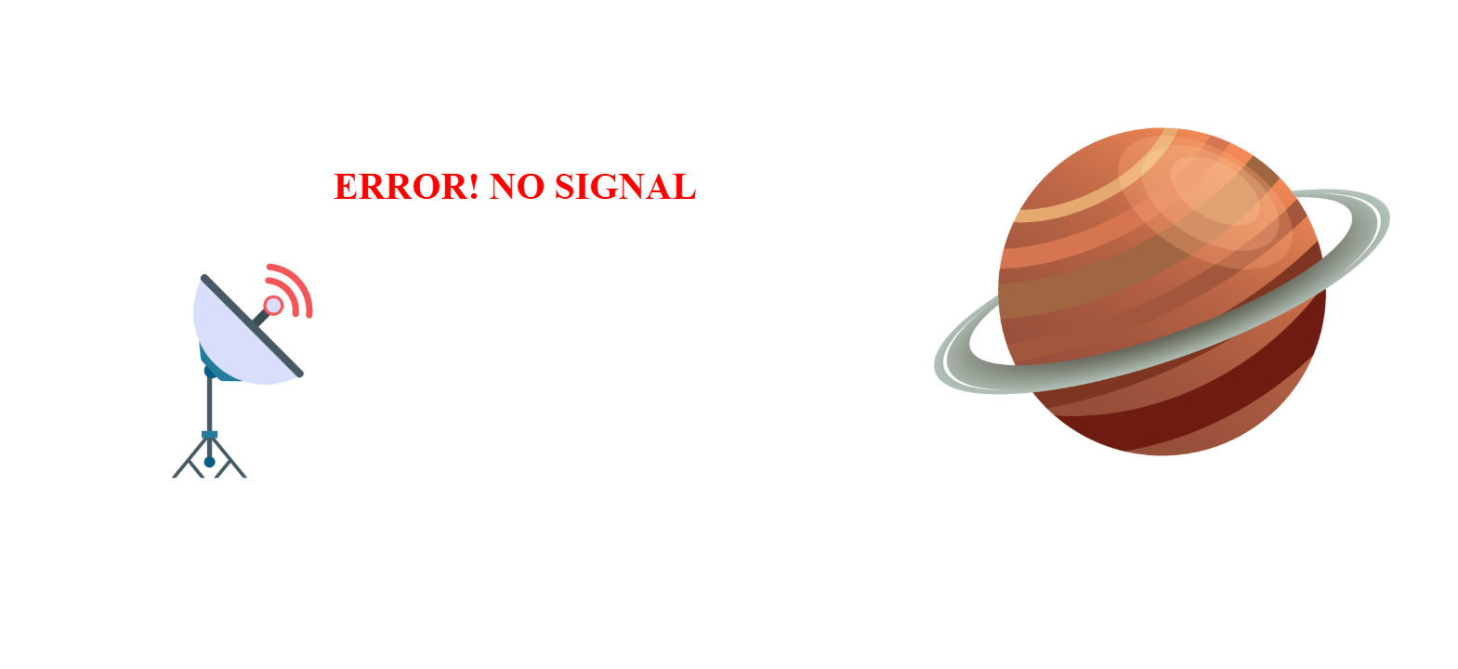

Fix Me
50
You've come across a mysterious file that refuses to open the usual way. Your goal is to uncover its secrets.
Flag Format: H4G{flag}
Leaked Coordinates
100
You received a leaked file containing a set of GPS coordinates tied to an underground operation. To obscure their findings, the whistleblower hashed each coordinate pair before sending the file.
Your mission is to analyze these encoded coordinates, determine their real-world distances, and identify:
- The closest pair of GPS coordinates — a potential meeting point or stash.
- The farthest pair of GPS coordinates — possibly two locations used for diversions.
Flag Format: H4G{coordinateID1-coordinateID1,coordinateID2-coordinateID2}

Sounds Deep
150
You’ve come across a .wav file that seems like ordinary audio. However, there's something off about the way the sound behaves. Listen closely, and you may notice more than just sound—there’s a hidden aspect that isn’t immediately audible. Hint: The file appears to be just another recording, but not everything is conveyed through sound. There’s an unexpected detail if you dig a little deeper.
Flag Format: H4G{flag}

The Truth Lies in the Spaces
200
A ZIP file has been discovered, containing multiple files. Your mission is to retrieve the flag.
Flag Format: H4G{flag}

Matcha Mystery
100
🍵 Matcha Mystery 64 🍵
A shipment of fine matcha has gone missing on the way to the Tea House. Check Every Room, Enter, Make Observations, Notice Interesting Aromas, and Learn.
Can you trace the clues and recover the final flag?
Flag format: H4G{Answer}
SonarSweep
150
They’re hiding something and all you have is a sonar recording. You intercepted a transmission from a fleet, encoded as audio. Each ping reveals something... if you can read the waves.
Can you locate all the ships on the grid and take them out?
Just one mistake, and you're sunk.
Flag Format: H4G{flag}

PortTiming
150
The port is open... but you won't get the flag unless you enter the right password. The catch? It's only 6 alpanumeric characters long. Every correct guess gives you a subtle clue if you're paying close attention to the timing.
Think you can outsmart time? Just like Wordle, but with time?
IP: 172.16.101.205:5002
Flag Format: H4G{flag}

Shadows at Reichenbach
200
"The dusty archives of Baker Street have recently been opened, revealing what appears to be a forgotten manuscript about Sherlock Holmes and his infamous rival, Professor Moriarty. The pages are filled with tales of disguises, train journeys, and whispered conspiracies across Europe. Scholars believe it to be nothing more than a retelling of the legendary encounter at the Reichenbach Falls. Yet rumors persist that Doyle’s manuscript was altered by someone, perhaps Moriarty himself, embedding hidden secrets in the illustrations and marginalia. Of course, it could simply be a Victorian story about disguises, suspense, and moral lessons. Surely there is nothing more to it… or is there?"
Flag Format: H4G{flag}

Noisy Neighbors
100
The network has turned into a noisy neighborhood—packets flying around like neighbors who won’t stop singing late at night. Most of it is the usual chatter: HTTP, DNS, ICMP, even some FTP. But one device is trying to send a real message. Can you filter through the noise and catch what the client is quietly slipping through?
Flag Format: H4G{Answer}

NFS Leak
100
A rogue employee leaked files over NFS. Can you sift through the PCAP and recover the stolen flag?

Flag Format: H4G{flag}

Echoes of a Keylogger
150
Deep within the captured file lies a faint pattern. It is not just random traffic, but a keylogger at work.

A single XOR, familiarity with HID usage tables, and clearing the redundancies might illuminate the echoes.

Flag Format: H4G{flag}

Paws and Packets
200
Bisquet (a Golden Retriever) and Hassie (a Shih Tzu) are Sasha's office dogs. Sasha is TreatlyTech's lead developer and usually showers them with love and treats. But lately, the treat supply has been suspiciously low.

The dogs aren't mad. They are disappointed.

While Sasha is away at a beach for the company annual planning, Bisquet and Hassie seize the opportunity. Using Sasha's unlocked workstation, they dig through her stuff. The flag fragments are hidden in five different protocols which contains Sasha's browsing history, internal emails, suspicious DNS queries, "barks" inside ping packets, and unreleased source code.

Flag Format: H4G{part1_part2_part3_part4_part5}

Revenge 0
0
A worker left the company, but they didn’t leave quietly. They were angry about how they were treated and wanted to get back at the company. Before walking away, they secretly put together a folder full of files and leaked it. At first, the folder just looks like a bunch of random stuff. But hidden inside are the company’s secrets. The ex-employee buried the real clues in places most people don’t usually check. They wanted to damage the company’s reputation and you’re the one who has to uncover the truth.
Flag Format: H4G{RevEng30fD'F@lL3n}
It's Pay Day! 0
0
Last September 10, 2025, Joe reported to the SOC team about an email that he received. He told the team about a client not receiving his payroll. Why is it so?
FLAG: H4G{p@Y_D@y!}

Daily News is UP! 0
0
A newly hired employee in the Cybersecurity Division was looking through some old cyber news advisories. He noticed that an unknown sender from the Central Office sent him an email pertaining to a new advisory. He warned his whole team that it was a recent event. Help them look into the details through this advisory link:

NEWS ADVISORY LINK: https://pastebin.com/K8y8PYDs

Note: You must follow the numbers of the zip files

FLAG: H4G{d@1Ly_n3W$}

Serpent's Glitch 0
0
A contact of mine, who goes by the handle @rykardthe2nd, claims he managed to sneak something onto my system. Ever since, my machine has been crawling. He says it’s a “test” before I can join his crew. He wants me to answer a series of questions — but the only clue he left behind is his online handle.

FLAG: H4G{s3rp3ntsGL!tCH}

Revenge 1
10
What is the name of the analyst involved in the leak?
Flag Format: H4G{Answer}

Serpent's Glitch 1
10
What tool was used to extract the image metadata?

Flag Format: H4G{Tool Name}

Serpent's Glitch 2
10
What is the SHA256 hash of the malicious file?

Flag Format: H4G{Hash}

It's Pay Day! 1
10
What is the email message ID?
Flag Format: H4G{Answer}

Daily News is UP! 1
10
What is the date and time the event occurred? Format: mm-dd-yyyy 00:00:00

Flag Format: H4G{Answer}

Did you hear that?
50
It’s just static… or is it?

Behind the noise, the real challenge is knowing the name of the silent strike that came after a famous 2010 worm.

Flag Format: H4G{flag}

Unzip me
50
The world was hit by one of the most damaging ransomware attacks ever. Hospitals, businesses, and even governments were locked out of their systems. But like any mystery, the attackers left small clues behind.

Your mission is to act like a cyber detective. Trace the path and you’ll put everything together to unlock the final flag.

Remember that all flags are case-sensitive

Flag Format: H4G{Answer1_Answer2_Answer3_Answer4_Answer5}

noble woman
60
Last year, we captured and tagged the "Noble Woman" of the ocean!

Today, we're wondering when was she was last pinged.

Flag format: H4G{Full Month Day, Year, 00:00:00 AM/PM}
stop, look or listen
100
A mysterious folder of noisy WAV files appeared on a dark forum. Management dismissed it as static, but whispers say it hides the identity of the hacker who left it behind.

Can you bridge the gap to reach me? Seal the full picture with a hash, and let me be revealed

Flag Format: H4G{Answer}

